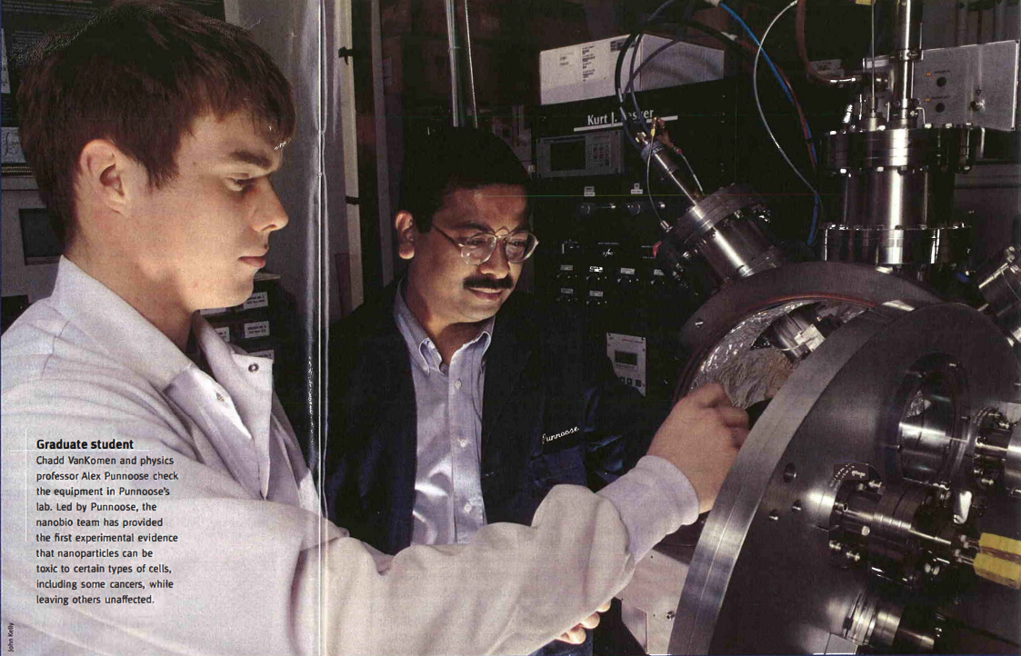
Graduate Student – Chadd Vankomen and physics professor Alex Punnoose check the equipment in Punnoose’s lab. Led by Punnoose, the nanobio team has provided the first experimental evidence that nanoparticles can be toxic to certain types of cells, including some cancers, while leaving others unaffected.

Nanobiotechnology by Mike Journee
“Humans are in a war with microbes and we’re losing.”
The stark reality of that statement, a quote from the professor of a microbiology class at another university, took Boise State physics professor Charles Hanna by surprise, despite his years of scientific training and a general understanding of its truth.
Today, it serves the theoretical physicists as a reality check of sorts. It reminds him that the task facing a small group of biologists, physicists, engineers and chemists from Boise State is nothing short of monumental. The dizzyingly-fast mutations of bacteria and other microbes – the cause of often deadly infections increasingly plaguing hospitals and their patients – have been perplexing scientists since the invention of antibiotics.
Despite the odds, when Hanna, Alex Punnoose, Denise Wingett, Kevin Feris and other members of Boise State’s “nanobio” group (short for nanobiotechnology) talk about the promise of their work, their eyes light up. They know that their work could one day be the foundation for effective treatments that could save grandparents from infections while being treated for pneumonia and grandchildren from the agonies of leukemia.
They believe that the varied backgrounds, expertise and perspectives of this highly interdisciplinary team of researchers is starting to unravel a new world of possibilities.
They hope that using nanotechnology to answer fundamental questions of biology and medical research will not only help fight mankind’s war against microbes, but aid in our long-standing pitched battle with cancer as well.

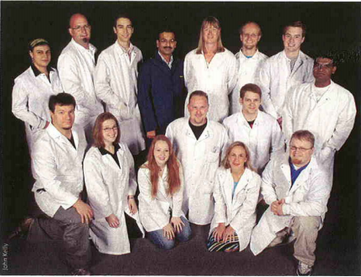
Team members pictured here are (front; left to right) Nathan Dewey, Lydia Johnson, Janet Layne, Andrew Coombes, Cory Hanley, Aaron Thurber, Tommy Chartier, (back row; left to right) Mary Ann Sabetian, Jason Cristensen, Josh Anghel, Alex Punnoose, Denise Wingett, Isaac Coombes, Chadd VanKomen and Madhu Reddy.
The promise of the group's work is built on nanoparticles -very small pieces of often common materials that measure between one and 999 nanometers (a human hair is about 100,000 nanometers wide). At nanoscale size- as the materials become smaller and the ratio of their surface area to volume increases -everyday materials can become fabulously versatile and unpredictable. For example, a sample of copper, normally known for its malleability, becomes super hard in pieces smaller than 50 nanometers in length.
In other words, nanoparticles of familiar materials can do unfamiliar and, under the right circumstances, exciting things. The key, however, is to understand which ones do what.
Nanoparticles aren't just getting attention from Boise State scientists. No matter their fields of expertise, researchers everywhere are beginning to underst9nd that the realm of nanoparticles is a world of great scientific potential where spectacular discoveries almost certainly await. PAGE 16 I FOCUS I WINTER 2009 Led by Punnoose, a physics professor whose synthesis of nanoparticles previously focused on their use in semiconductors and nanoelectronics, the Boise State nanobio team has provided the first experimental evidence that nanoparticles can be toxic to certain types of cells while leaving others unaffected.
Punnoose conducted these initial experiments with Feris, an assistant professor of biology and a microbial ecologist, just over two years ago - marking the informal beginning of the nanobio team at Boise State. Since that time, the group has grown to include seven faculty-level members, two post-doctoral fellows, three graduate students and 10 undergraduate students, each with specific expertise in areas of interest for the group.
Feris and Punnoose's work using zinc oxide nanoparticles to kill certain types of bacteria led to the publication of a well-received paper and the inclusion of Wingett, a biology professor and cancer researcher, in their discussions and experiments. "Alex thought, 'well, if this works on microbes, what about cancer cells?'" Wingett says.
It was the nanobio group's most celebrated success -the discovery of an effective method for using zinc oxide nanoparticles to preferentially kill immune cell cancer while leaving ordinary cells healthy. It also led to the group's second paper, which created a buzz in the scientific sphere when it was published over the summer.
Wingett blanches at the word "breakthrough" - the experiments so far have only focused on immune cell cancers. Yet the discovery could, one day, become the basis for new cancer treatments that lessen, or possibly eliminate, the debilitating effects of chemotherapy. As the group's cancer expert, she will try to determine whether nanoparticles can be effective against other types of cancer.
It's heady stuff for an all-Boise State team of researchers. These experiments and findings are on the cutting edge of research. These scientists are the first to explore this particular corner of the nanoparticle world and its specific potential for deployment in mankind's microscopic struggle for survival.
"This is an extraordinary opportunity for an emerging research university like Boise State," says Wingett, who serves as the associate chair of the Department of Biology and is a Boise State grad (B.S., chemistry, '86). "Just think of the possibilities."
Nanoparticles inside human cells kill their hosts by disrupting the normal chemical reactions and structures a cell needs to survive. The lethal mechanism is not as clear with bacteria.
"We need to know more about why particular nanoparticles are effective and others aren't," Hanna says. "We need to know what happens when that nanoparticle gets close to the cell."
One idea, introduced by Hanna, is that the atomic charge of zinc oxide changes at the nanoparticle level, creating a fatal reaction with the outer membrane of the bacteria.
Atomic charge is behind another theory the group is working on called "functionalizing." By manipulating the atomic charge and other characteristics of a nano particle cluster, the team thinks the cluster can be used to "tow" chemotherapeutic drugs or other medications directly to cancer cells or infection-causing bacteria using a third agent. Using the natural attraction between opposing charges, medications could be delivered with better-than-pinpoint accuracy, allowing for a greatly reduced dosage.
Hanna's role with the group is largely limited to theoretical "what would happen if " kind of work; he quickly points out that the laboratory scientists are the ones doing the heavy lifting. Yet his idea that atomic charge could be one of the contributing factors to zinc oxide's effectiveness is a prime example of the benefits of interdisciplinary research.
"We all bring different perspectives to the problems we face, so it broadens the way we look at solutions," says Hanna. "The really innovative thinking comes from the areas where the outer edges of our various disciplines overlap."
It creates a dynamic where both faculty members and students are moving out of their comfort zones and learning in areas outside of their typical silos. Students particularly benefit from working so closely with scientists from another discipline.
"Students tend to think about science only through their own area of focus," Feris says. "We have some engineering and physics students who are learning to think like microbiologists. It's really broadening everyone's perspective, including my own."
The various individual researchers bring specific expertise to particular areas of interest for the group.
Hanna, a theoretical physicist, will create "predictive models" to map nanoparticles with specs known to be effective, which can then be manufactured in Punnoose's laboratory. He also provides insight into the physical reactions that biologists observe in their experiments.
Juliette Tinker, a biology professor and microbe specialist, will continue studies on the potential for treatment of increasingly dangerous bacterial infections using nanoparticles.
Wingett and biology professor Kristin Mitchell are starting to work on in vivo or living cell experiments with mice to, among other things, determine the most effective dosage levels for various nanoparticles. These experiments with mice are the first step toward human testing and, ultimately, bona fide treatments using these techniques. If all goes perfectly -a big if-testing and final approval of such treatments could happen in about a decade.
By covering so many areas of specific expertise, the team also will be more likely to attract all-important funding from organizations like the National Institutes of Health and the National Science Foundation, which actively seek opportunities to fund innovatively promise of their work has attracted more than $1 million in grants to buy equipment needed to expand the scope of their research -just a drop in the bucket for what would be needed to ultimately develop treatments.
"It's really just a matter of time before we rope in a big grant," says Feris, the microbial ecologist who will help the team understand the "environmental fate" of nanoparticles or how their use will impact the environment, a key question if these methods are ever to become widespread.
Moving forward will take a lot of time, sweat and money. "But," Wingett says, "it's worth it."
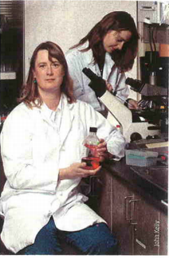
Biology professor Denise Wingett works in her lab with graduate student Alma Hodzic. Wingett guides the nanobio group's cancer research, which includes the discovery that zinc oxide nanoparticles can kill certain types of immune cell cancers while leaving o ther types of cells unaffected.

