Nscrypt Conformal Printing

Steps to conformal print on the Nscrypt

1. Load Path File
2. Move platen so tip is above 0,0 position of your drawing.
3. Click on “Conformal” in the tool bar

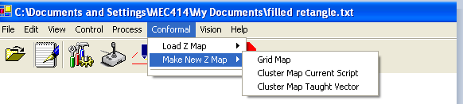

1. Click on “Cluster Map Current Script”
2. On popup click on “Teach XY Point 1”

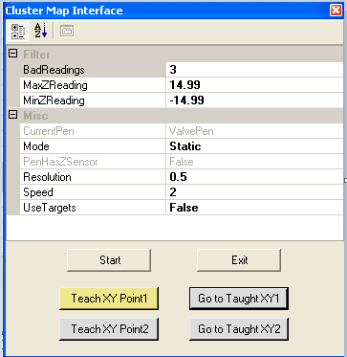

1. Open PEN Control and load the LKSensor
2. Back on the Cluster Map interface click “Go to Taught XY1” Z axis should raise up and the platen should move so that the laser is now positioned at the desired start location of your print.
3. Set the speed and resolution. Resolution has to be higher than 1/10th the speed. For example if you wanted a resolution of .1 the speed must be 1 or lower.
4. If you have a substrate with a large amount of z profile set the Mode to dynamic.
5. On the Resource Control Menu click on the AI tab on the left side. AI reading is the laser feedback. Move z down until the reading is ~0.0. A reading of +/-9.99 means the laser isn’t getting feed back.
6. On the Cluster Map Menu click the start button. The platen should start moving following your script lines.
7. If z map fails for too many bad readings. Set the bad readings to 3. Go back to step 7 and try again.
8. After successful completion save Z map.
9. On the main screen Click on the Conformal drop down use the load Z map option and click on Cluster Map. Load your file.

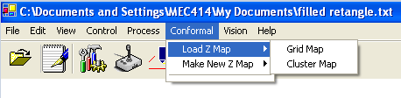

1. On the resource control tab Load the valvepen.
2. On the Cluster Map Menu click “Go to Taught XY1” again the z axis should raise and the platen should move to a position that puts the tip over the starting position.
3. On the resource control page move the z axis all the way down until you have the desired tip/substrate clearance. Make note of the z position reading.
4. On the Main screen open the Run Form Menu.
5. Click the “Teach XY1 position”
6. Change the dry run and the use z map to true
7. Set the clearance to the desired clearance. Usually ~.2
8. Click Start. Z will move up 25mm above start position
9. Click Ok.
10. A popup says move to Z position “xx.xx” make sure that this number is not lower than the Z position you recorded earlier. If it is cancel and increase your clearance. If you have to change your clearance go back to step 21.
11. If the z height is ok click OK. Your script commands are being loaded into the buffer so depending on the number of lines in your drawing it might take a little bit. The z axis and the platen should start moving and following all the lines in your drawing. Watch the upper screen making sure that the tip/substrate clearance remains consistent.
12. If the clearance was good during the dry run. Click to ‘Go to taught XY1” position.
13. Change Dry run to false.
14. Click the Start button
15. Verify Z positions are still ok. Click OK
16. Watch upper monitor and verify that paste is being dispensed.